**Kronos Kidnapping**

Heather Lemon

Department of Computer Science, University of Denver

COMP 4449 Capstone Final

Dr. Claudio Delrieux

May 24, 2023

**Kronos Kidnapping Case by Heather Lemon - Introduction**

Kronos is a small island off the Mediterranean coast, home to people of traditionally agricultural farming and timber. In 1994, Sten Sanjorge Jr. discovered oil and gas fields in the country which led to the expansion of GASTech company in Kronos.[4] The Kronos government has pivoted toward energy, specifically natural gas, and financial services. As a result of corruption and poor government planning, many Kronisians have struggled to make the transition with unemployment hovering around 24% and 70% at or below the poverty line. Kronos currently suffers from natural gas pollution with contamination in the water and soil, hyper acidic substrate removal, loss of arable land, deforestation. Kronos transnational issues - a transshipment point for heroin and hashish to Europe; despite a strengthening of anti-money-laundering legislation, remains vulnerable to money laundering; corruption is a major concern; reporting of suspicious transactions in offshore sector remains weak. [0][2]

Tethys is located near western Europe bordering the Mediterranean Sea. It is a large and populous country (32 million+) with a diverse economy and high tax rates. It’s central GDP comes from the services and industry workforce. With environmental issues such as air pollution, deforestation, climate change, and hazardous wastes. Tethys transnational issues - include it being a transshipment point for cocaine, heroin, marijuana synthetics, money-laundering for narcotics trafficking organizations and organized crime. [1]

The Protectors of Kronos (POK) is a political activist movement that began as a small group of seven citizens concerned about contamination from drilling at the Tiskele Bend River gas fields. The protectors of Kronos emerged from the Elodis township, a rural agricultural town of about 6500 persons that lies 25 km from Abila, capital city of Kronos. In early 1997, citizens of Elodis began to be concerned about an abnormal increase in the occurrence of illnesses such as cancer, birth defects, respiratory illnesses, and neurological diseases. WFA tested water from the Tiskele River both upstream and downstream of the Tiskele Bend gas fields and confirmed the presence of contaminants consistent with pollution from Hyper Acidic Substrate Removal, a gas drilling technique employed by GASTech at the Tiskele Bend fields. The WFA published these test results in several international journals. [0]

GASTech has been in Kronos since the discovery of the oil and gas fields since 1994. GASTech’s current CEO is Sten Sanjorge Jr. In January 2014, the senior executive members were celebrating a fortune made from the initial public offering (IPO) when several of the GASTech employees went missing. We will try and bring law enforcement up to date on the current organization of the POK, how has it changed over time, who are the key leaders, explanations of why the GASTech employees went missing, and what is the timeline of events surrounding the kidnapping of January 20-21, 2014.

**Kronos Kidnapping Case – POK Early Years**

Protectors of Kronos (POK) was founded by Henk Bodrogi in 1997 and six other co-leaders; Carmine Osvaldo, Ale L. Hanne, Jeroen Karel, Valentine Mies, Yanick Cato and Joreto Katell; out of concern for the citizens of Elodis township where sickness and death has increased since the drilling of oil and gas from an upstream river. [3] The POK members appealed to the Minister of the Interior armed with health statistical reports and testing reports for toxic chemicals from water contamination of the nearby Tiskele River. The initial results from the WFA water testing in 1998 found high levels of chemicals associated with Hyper Acidic Substrate Removal, and technology associated with natural gas drilling operations. Several toxic substances were found Elodis water, including benzene, toluene and xylene arsenic, barium, chromium, lead and selenium. [14] WFA published these results in international health organization conferences, bringing increasingly widespread awareness of the Elodisan situation. They received nothing but skepticism and silence from the government. They began to reach out GASTech representatives, but they were also silent until Hank Fluss Chief Operating Officer meet with members of the POK and took his concerns to Sten Sanjorge Jr.

**Kronos Kidnapping Case – Timeline of Events up until the kidnapping (1998-2013)**

In 1998, Juliana Vann passed away from leukemia associated with benzene toxicity. This spurred more support for the members of the POK. [3]

POK continued to press the Kronos government for answers, but all their efforts are blocked. In March 2001 Minister Nespola died suddenly. Shortly after President Kapelou accounted his nephew Vincent Kapelou would succeed as the new Minister of Health.[13] Later in the year an underground methane deposit ignited at the GASTech mining operations near Elodis. During which time afterwards there were protests begun at the GASTech fields and several POK activists were arrested. Later in October of 2001, Elian Karel was now the new leader of POK. However, they added a item to the agenda to include bribery and corruption of governmental officials. [3] In the following years 2005-2009, protests from the POK being more militant, violent, and civil disobedient.

In March 2009, Elian Karel was held in Abila City Prison on alleged tax evasion charges. [5] Where he later died of a heart attack in June 2009. [5] But conflicting reports show he was in allegedly beaten to death [6].

The POK has evolved from peaceful protests and demonstrations demanding government action to more violent activities including riots as they claim that the government has done little to nothing in addressing the contamination, poisonings, and deaths suffered by their people. As of 2011, the Government of Kronos has labeled the POK as a "public threat" and GASTech employee Sten Sanjorge Jr calls them terrorists. [7][11] POK protest continue after the death of Elian Karel with Silvia Marek taking over as the new leader. [8] Four POK members were arrested on false drug charges [9]. Many news articles point to an increase in drug trafficking, drug usage, money laundering, and corruption. [10]

Bianca and Arresta said their efforts to treat people has been made more difficult because they often do not know anything about the designer drugs that were taken.

"We have had patients come in and act out of control, who are very violent. They tell us they have been doing cotton candy or synthetic marijuana."One factor for the popularity of cotton candy is its low cost, Bianca said. She said a gram of cotton candy costs about K18 while a gram of cocaine costs K166. Cotton candy creates euphoria, or a high, that is equal to or greater than that of cocaine but also causes a crash that is worse, Bianca said. The crash's ill-effects often prompt people to binge on cotton candy to the point where they consume the drug for days. "They crave it," she said. The Asterian People's Army (APA) has traditionally been involved with drug trafficking throughout the region, and enforcement agencies are closely examining possible cooperation between drug trafficking organizations and political insurgent groups. "We had at least two cases dozen in last month," said Alicia Bianca, director of nurse of the department. [16] Khat or qat is a flowering plant native to eastern and southern Africa.[2] Khat contains the alkaloid cathinone, a stimulant, which is said to cause excitement, loss of appetite, and euphoria. [15][10]

At an anniversary vigil for the deaths of Juliana Vann and Elias Karel police were reported using pepper spray and batons against those who attended the ceremony. [12]

**Kronos Kidnapping Case – The Kidnapping (January 2014)**

The morning of January 20th 2014 a fire alarm went off at the GASTech headquarters.

**Kronos Kidnapping Case – Two hypotheses for missing employees**

1. Did the CEO and senior executives fake a kidnapping and steal the money and run away?

2. Did the POK kidnap the CEO and executives to extort money for funding drugs, corruption, and bribery?

My hypothesis is that both incidents occurred. I think the senior member executives did steal the money and run away.[article 713] I believe the CEO was kidnapped by the POK and the other senior executives knew about it and let it happen as a distraction for themselves so they can run away. CEO Sten Sanjorge Jr was later found the next day back in the capital city Centrum, Tethys. The news report [824] shows the POK has taken responsibility for the kidnapping but also a ransom demand of $20 million from the CEO.[824] This news article 460, mentions the names of five executive employees including; Sten Sanjorge Jr, Ingrid Barranco, Ada Campo-Corrente, Orhan Strum, Willem Vasco-Pais. [460]. This still leaves 9 people missing [676]. A conflicting report by the police suggest that the police do not believe the people missing have left the island which conflicts with the report [824], where the CEO arrived in Tethys.

**Kronos Kidnapping Case – Dataset Description**

We have been given; a map of Kronos, an org chart of GASTech, employee records, email headers of two weeks prior to the kidnapping, a few employee resumes, factsheet of Kronos and Tethys, and historical reports, and news articles.

We needed to do some data cleaning and preprocessing around the email content.

**Figure 1**

*Dirty Email Header Example*



There were a handful of GASTech employee records that has missingness in the data. It was either due to the employee did not own a passport or the employee did not serve in the military. Since the missingness is intentional, we chose to keep the missing data.

NLTK was used to clean the subject category of the email headers and news articles. Such as replacing commas, using lower case, and removing all punctuation. For the news articles, we extracted the name of the news company, the datetime stamp which the news article was reported, a feature engineering request to append the word “article” to each of the 845 news articles to tell where we got the news from.

**Kronos Kidnapping Case – Exploratory Data Analysis**

To help answer the questions above, a social network communication graph was created of the GASTech email headers data. A question was asked – How frequently do employees contact each other via email. For example: Ada emailed Felix two times. We can take the email headers csv file and transform it into a source, target, weight. Where the source represents the *From*, the target represents the *To* and the weight is the frequency at which emails were sent to other employees. I initially drew a chord graph from d3blocks but found that there wasn’t much insights about the communication between employees.

**Figure 2**

*D3Blocks Chord Communication Graph*

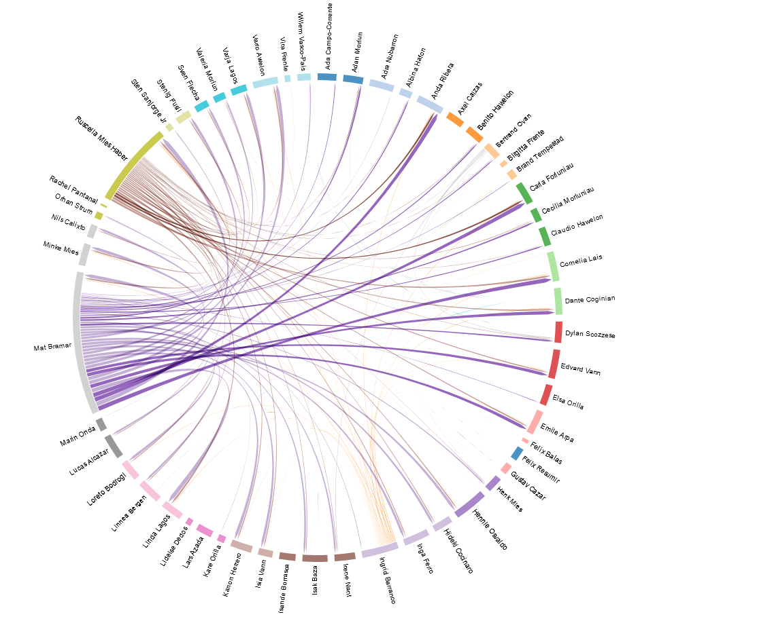

*We don’t have a lot of insight here on who specifically is connected to whom.*

To elaborate further on the communication network, we would like to know which employees communicate with each other and what they talk about. It would have been nice to understand more of the context of what people were talking about. We lost that context when we did the transformation for getting the email frequencies counts. To elaborate further, you can train a clustering algorithm to group employees based on their email metadata or content. By analyzing the content of emails, we can easily identify groups of employees who are discussing similar topics or engaging in similar activities.

**Figure 3**

*Social Network Graph by Gephi*

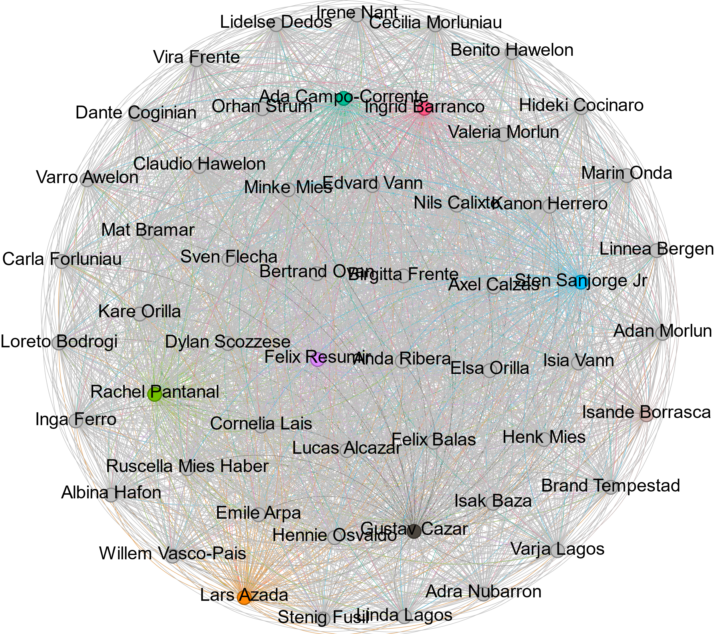

*Figure 1 – Social Network Graph by Gephi*

The brightly colored nodes are the employees with the most frequent communication with each other. To use Gephi, you must have a source, target, and weight. The weights represent the frequency at which employees communicated with each other.

We also assert that the employee's email address is in the employee records csv file. We discovered that Sten.Sanjorge Jr has two email accounts: Sten.Sanjorge Jr.@gastech.com.kronos & Sten.Sanjorge Jr.@gastech.com.tethys

The names listed are PoK symaptizers. Their citizenship is from Kronos, served in the military experience as well as sending out email contents of defenders of Kronos propaganda.

1. Ruscella Mies Haber
2. Isia Vann
3. Loreto Bodrogi
4. Inga Ferro

The Asterian People's Army (APA) is a paramilitary organization which has been engaged in terrorist activities funded through its criminal enterprises, which include drug trafficking. In recent years the APA has sought to build their brand through websites and the publication of a professional, high-quality magazine called "Arise". [article 775]

**Kronos Kidnapping Case – Facts vs Opinions on News Articles**

Briefly wanted to point out the news articles of facts vs opinions. Sentiment analysis was performed with the help of the Pattern library. The Pattern library has two main functions one is sentiment analysis, the other is the concept of modality. Modality is a rating from 0 to 1 if some sentence sounds more like a fact it is closer to 0 and if it sounds more like an opinion it’s value is closer to a 1. Here are a few graphs depicted of the overall modality scores of all news companies and the events surrounding the kidnapping during January 20-21st.

**Figure 4**

*Overall sentiment modality*

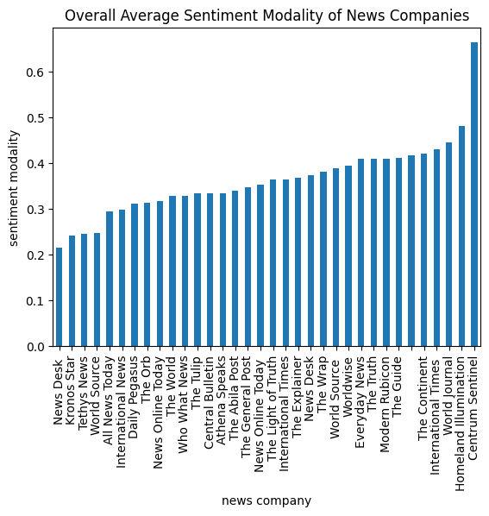

**Figure 5**

*Sentiment Analysis of News Articles over Time ~20 years*

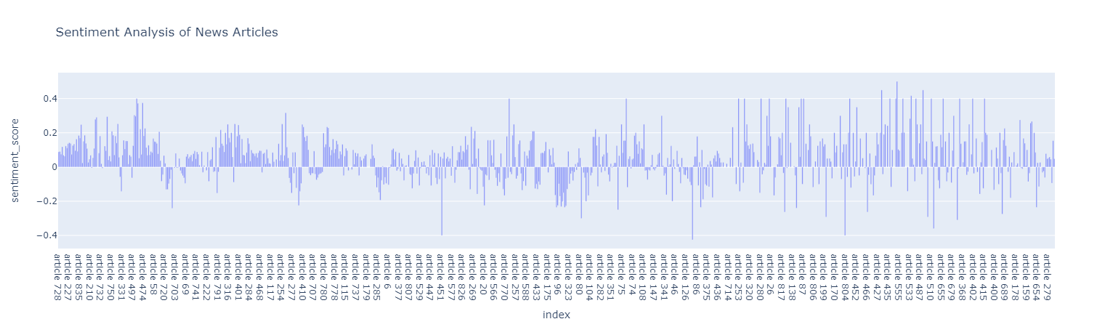

How people report about the news was initially positive but as protests become more violent and more deaths occur, we see more of a mixture of positive and negative sentiment over time.

**Figure 6**

*Sentiment Modality of News Articles over Time ~20 years*

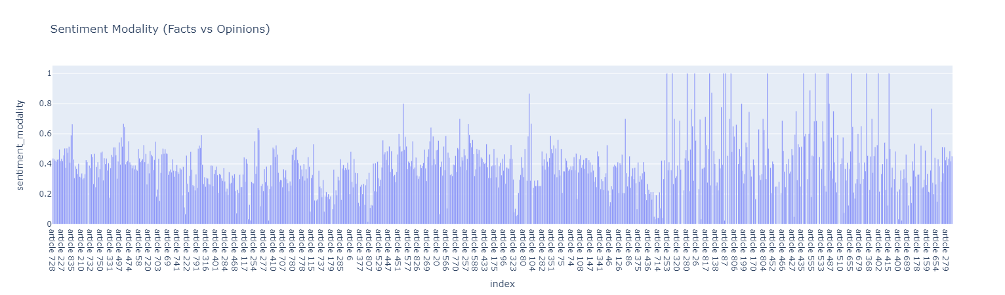

The sentiment modality score has increased over the years and news organizations are reporting more opinion based articles than facts.

**Kronos Kidnapping Case – Conclusion**

**Kronos Kidnapping Case – References**

[0] FACTBOOK-Kronos.docx

[1] FACTBOOK-Tethys.docx

[2] Historical Documents 5 year report.docx

[3] Historical Documents 10 year report.docx

[4] article 802.txt

[5] article 836, 798, 820, 683, 73

[6] article 161, 225, 745, 623,

[7] article 54

[8] article 320, 767

[9] article 266

[10] article 345, 839, 775, 651, 661, 687, 513, 530

[11] article 716

[12] article 753, 670, 572

[13] article 746

[14] article 254

[15] <https://en.wikipedia.org/wiki/Khat>

[16] article 651, 287